**MCU Assignment**

**Q.1)**

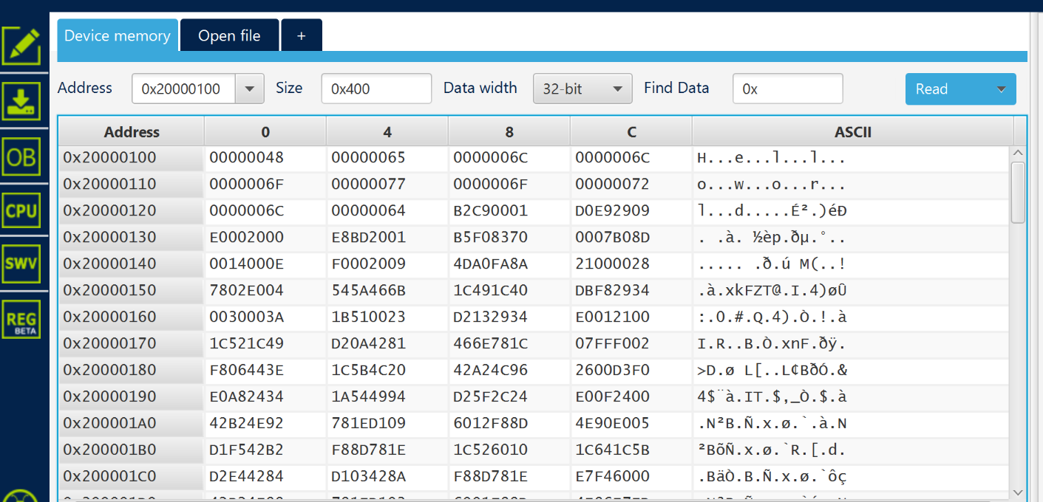

**Q.2)**

**portB pin 14(LED 2)**

**Led ON:**

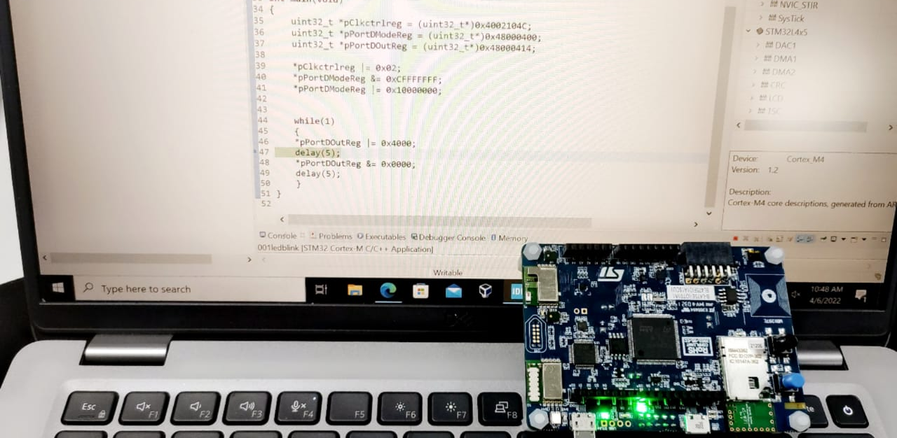

**LED OFF:**

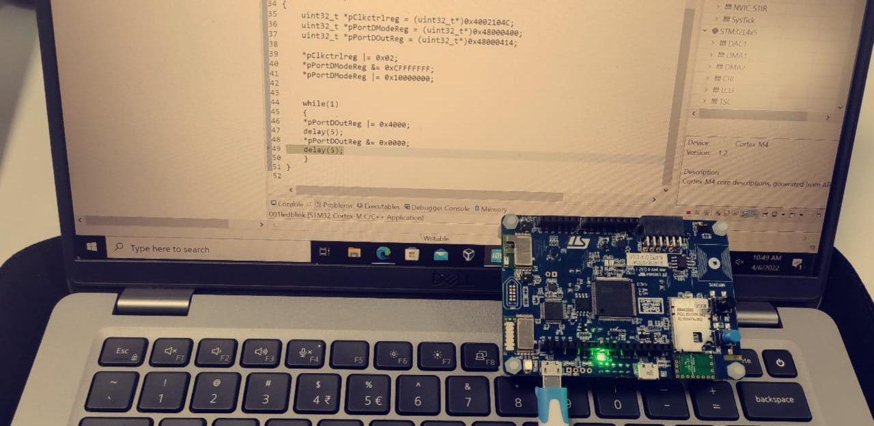

**Both led PA5 and PB14**

